Parklands
Junior School

Pupil Mobile Phone Policy

Inspiring Success

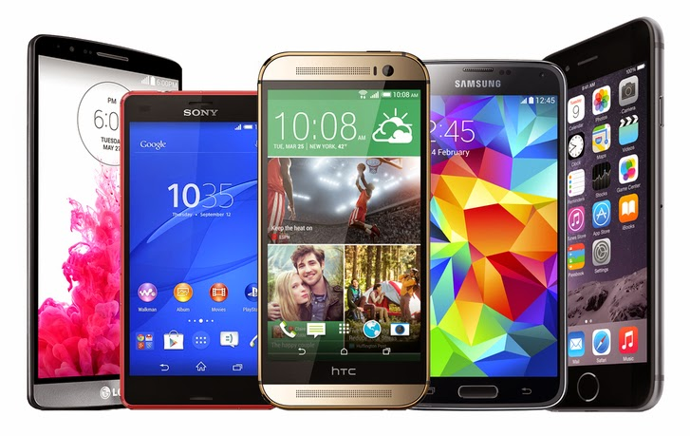

Pupil Mobile Phone Policy

We are committed to maintaining a welcoming and supportive learning environment in which all pupils feel valued and are challenged to be resilient thinkers, active learners and have an appetite for learning. At Parklands Junior School, all pupils are valued, inspired and respected within our happy and welcoming school community. We set high expectations for all pupils and we give every the opportunity to experience success in their learning by providing a relevant and challenging curriculum with an emphasis on personalised learning. All children have unique experiences to share. At Parklands Junior School, we celebrate this diversity by valuing the contribution of all pupils and providing an environment that encourages interdependence and autonomy in their learning.

Mobile Phone Use

Our school is committed to safeguarding and promoting the welfare of children. We expect all adults to share this commitment. The school permits the use of a phone for the primary purpose of ensuring the safety and wellbeing of Year 5 and 6 pupils. Only Year 5 and 6 pupils are permitted to bring a mobile phone to school as long as they abide by the following terms of use:

- The phone is to be used for the specific purpose of communicating with parents or carers on journeys to and from the School.
- Texts sent to a parent or carer to report arrival or departure.
- Advising parent or carer of a change of plan.
- Informing parent or carer of cancelled club and change of arrangement arising from that emergency.

Other Media Devices

The usage of other mobile devices including computer tablets and Fitbits / Iwatches are not permitted for any pupil. If a pupil brings in another device besides a mobile phone it will be confiscated and returned to the parent or carer at the earliest opportunity.

Liability

The school accepts no responsibility for any loss or damage to mobile phones brought into school. Any device brought onto the site is entirely at the pupils/parents own risk. We therefore recommend and encourage the pupil to be provided with a cheaper model of phone. Mobile phones must have the child’s name on the back or they will not be accepted.

Keeping Devices Safe

All mobile phones must be handed to the class teacher at the start of registration. The class teacher will lock the phones away until the end of the school day, when they will be returned to the pupil. No access to the phone will be allowed during the school day. The pupil will ensure their own phone is clearly marked and turned off when it is handed to the class teacher. Phones must not be left in pupil’s bags, coats or folders etc. If a phone is found outside of the specified storage location, it will be confiscated and not returned to the pupil. Parents or carers will be required to collect the phone from the school office at the end of the school day.

Restrictions

Mobile phones are not to be used for the following:

- Photographs or video footage taken within the school or on school premises of either pupils or teachers.
- Photographs or video footage taken at third party events on site, for example, fairs or discos.
- Messaging other children.
If we are made aware that a phone has been used for the above purposes without permission, we will ask the pupil to delete the images. This is to preserve the privacy of others in the school community. If it is discovered that a phone has been used to facilitate bullying or harassment we will initiate an investigation and may involve agencies including the police.

Sanctions

Any infringement of these terms and conditions will lead to the phone being confiscated. The parent or carer will be contacted and asked to come in to see the Headteacher or Deputy Headteacher and to collect the mobile phone at the end of the school day and a record will be made of the incident. If a pupil has their phone confiscated three times then we reserve the right to withdraw the privilege of allowing the pupil to bring a phone to school. The school will treat breaches of this policy as they would treat any other breach of school rules or behaviour and policy.

